Project Plan

On

**S-Board**

Submitted

by

Jaya Sai Krishna Muppalla Naveen Kumar Miryala

Krishna Chaitanya Nalluri Sai Rahul Pavuluri

**PROJECT GOAL AND OBJECTIVES:**

**MOTIVATION:**

The main aim of this project is to regulate all the In-class activities by the students through an online service so that all students can easily access them. The student can be aware of his evaluation reports, class participation reports through this online service as well as the lecturer can be aware of the student involvement regarding the course activities.

**SIGNIFICANCE:**

A student can rise a doubt on a particular topic which can be answered by another students and if no one answers that question it will be forwarded to Teaching Assistant of the Professor. A student can find address of another student through our website so as to do discussion bases on a topics in course. Also the professor can conduct the pop quizzes, in-class exercises and assignments.

**OBJECTIVES:**

* Forming separate groups for project discussions that leads to group evaluations of the project batches.
* It improves the communication among the students so as to clearly understand the topics by using the discussion forms.
* Students can get immediate feedback on the assignments posted by the professor.
* Finding the location of the other students.
* Making note of attendance of the students

**FEATURES:**

* By using the Google charts, we can evaluate the performance of the student.
* By using google maps, we can search the student location.
* In-class notes can be written online, which is saved for the future reference.
* Making use of video calling system.
* Student can make discussion boards in class and can view threads.
* Group chats can be made for discussions

**RELATED WORK**:

It is just like a piazza forum in which instructor will make the students to discuss on the assignments or the projects that are going in the class at that time and making the students discuss among them and solve their problems by other students.

<https://piazza.com/>

**PROPOSED SYSTEM**:

The main requirements of this is to monitor all the in class activity of the students and also to provide a better communication among the students and making them understand the doubts raised by others. In that we have included student location services, google charts for their performance analysis and chatting application along with discussion forum as well. The students can make use of this system in the class when the teacher is discussing a problem and can solve it in the class the entire discussion is seen by professor or teaching assistant and can evaluate each student in class participation. Professor can take attendance and give pop up tests. Students when in home can share their location to other students as well for their home address.

**System Architecture and frame work specifications:**

We are planning to make our system which has a simple GUI and it has three major people like students as users, Teaching assistants, Professors as administrators. The students are added by the professors and a particular doubt raised by the person can only be closed by that person and giving the feedback of the answer most helpful given by the fellow students. Professor takes the attendance and pop up quizzes. If a doubt is left uncompleted then it can be forwarded to the teaching assistant or the professor.

Activity Diagram:

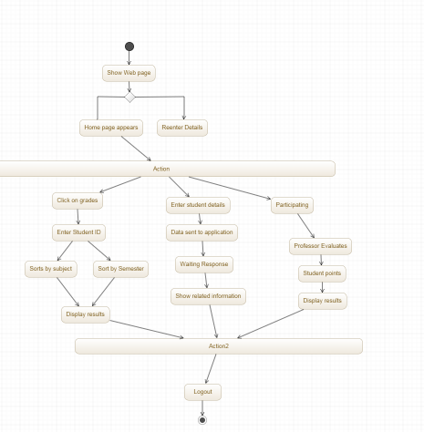

Use Case Diagram:

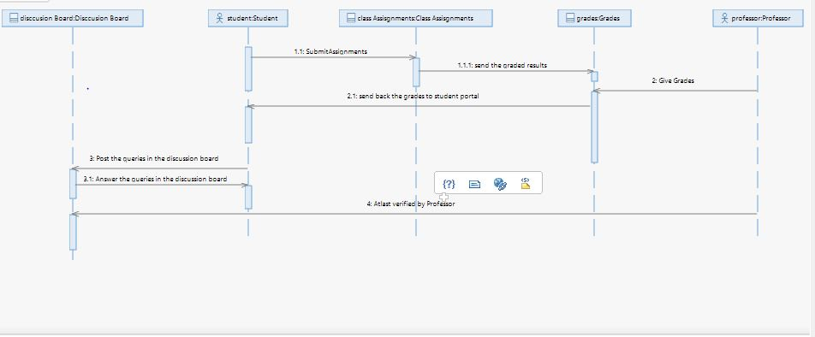

Class Diagram:

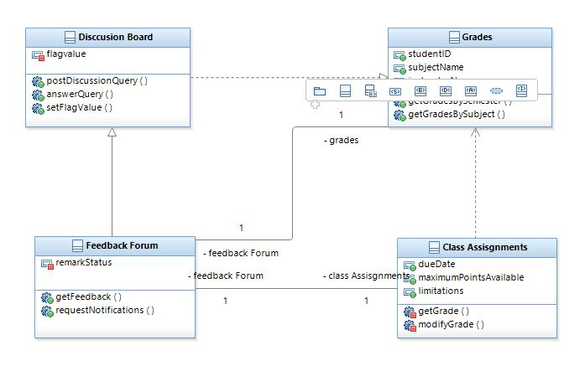

Use Case Diagram:

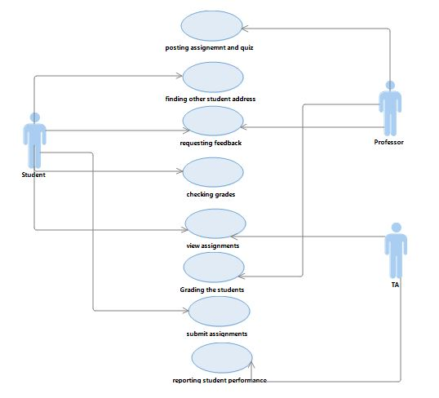

**PLAN BY SERVICE:**

The project is done in four increments with the last increment being testing and minor changes.

Increment 1: Collecting all the data and building the GUI of the system.

Increment 2: making use of the API’s and web services.

Increment 3: mashing up the applications.

Increment 4: Testing the applications and final patching of the project.

Scrumdo link: <https://www.scrumdo.com/projects/project/project1102/summary>

Github link: https://github.com/jmmvd/ase-project

Bibliography:

1. <https://piazza.com/>.
2. <http://developers.livechatinc.com/rest-api/>
3. <http://maps.googleapis.com/maps/api>.
4. <http://vsee.com/api>
5. http://msdn.microsoft.com/en-us/library/hh534080.aspx